**Deployment Guide**

1. Export from DEV

a. Create new YYYYMMDD (date of last run) subfolder of \\10.19.229.35\e$\Scripts\migration.fromDEV\Output and move existing content to that subfolder

b. Export Sync Server config (Identity Manager server export) to \\10.19.229.35\e$\Scripts\migration.fromDEV\Output\Server

c. Export FIM Schema (\\10.19.229.35\e$\Scripts\migration.fromDEV\exportSchema.ps1 which generates schema.xml file in ..\Output)

d. Export FIM Policy (\\10.19.229.35\e$\Scripts\migration.fromDEV\exportPolicy.Part1.ps1 which generates policy_part1.xml file in ..\Output)  
*** note: if not a first time deployment, or when no new schema has been created which will change the schema of the FIM MA, this step can be skipped ***

e. Export FIM Policy (\\10.19.229.35\e$\Scripts\migration.fromDEV\exportPolicy.Part2.ps1 which generates policy_part2.xml file in ..\Output)

2. Export from UAT

a. Create new YYYYMMDD (date of last run) subfolder of \\10.19.229.31\e$\Scripts\Output and move existing content to that subfolder

b. Export Sync Server config (Identity Manager server export) to \\10.19.229.30\f$\UAT.DeployFromDEV\Version1.3.UAT\Server.Save (set the folder version accordingly - this is purely for recovery/reference post migration)

c. Export FIM Schema (\\10.19.229.31\e$\Scripts\exportSchema.ps1 which generates schema.xml file in ..\Output)

d. Export FIM Policy (\\10.19.229.31\e$\Scripts\exportPolicy.Part1.ps1 which generates policy_part1.xml file in ..\Output)  
*** note: if not a first time deployment, or when no new schema has been created which will change the schema of the FIM MA, this step can be skipped ***

e. Export FIM Policy (\\10.19.229.31\e$\Scripts\exportPolicy.Part2.ps1 which generates policy_part2.xml file in ..\Output)

3. Copy/Rename files from DEV to UAT

a. Copy sync server config from \\10.19.229.35\e$\Scripts\migration.fromDEV\Output\Server to \\10.19.229.30\f$\UAT.DeployFromDEV\Version1.3.UAT\Server

b. Rename schema.xml in \\10.19.229.31\e$\Scripts\Output to production_schema.xml

c. Rename policy_part1.xml in \\10.19.229.31\e$\Scripts\Output to production_policy.xml  
*** note: if not a first time deployment, or when no new schema has been created which will change the schema of the FIM MA, ignore policy_part1.xml and rename policy_part2.xml instead ***

d. Copy FIM Schema schema.xml from (\\10.19.229.35\e$\Scripts\migration.fromDEV\output as pilot_schema.xml to \\10.19.229.31\e$\Scripts\Output

e. Copy FIM Policy policy_part1.xml and policy_part2.xml from (\\10.19.229.35\e$\Scripts\migration.fromDEV\output as pilot_policy.xml and policy_part2.xml respectively to \\10.19.229.31\e$\Scripts\Output  
*** note: if not a first time deployment, or when no new schema has been created which will change the schema of the FIM MA, ignore policy_part1.xml and rename policy_part2.xml instead ***

4. Sync Schema

a. Run \\10.19.229.31\e$\Scripts\SyncSchema.ps1 to generate .\Output\changes.xml

b. Run \\10.19.229.31\e$\Scripts\Output\TransformXML.exe to analyse changes.xml (hit Save and open generated html file in browser)  
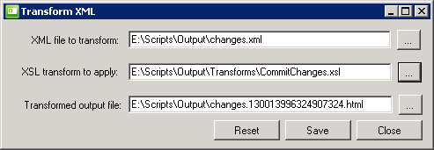  
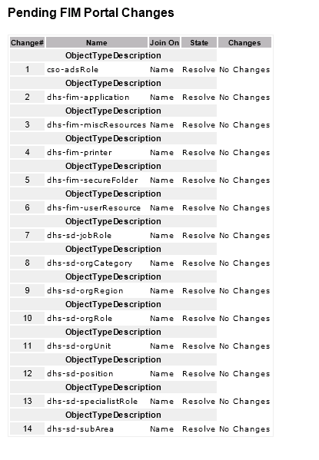

c. If no changes, proceed to step 5

d. Run \\10.19.229.31\e$\Scripts\CommitChanges.ps1 to apply changes in .\Output\changes.xml, and monitor output

e. Run \\10.19.229.31\e$\Scripts\Output\TransformXML.exe to analyse undone.xml (hit Save and open generated html file in browser)  
Note: undone.xml will only be produced if there are errors syncing changes ... analyse errors, and correct as necessary

f. Run \\10.19.229.31\e$\Scripts\resumeUndoneImports.ps1 to re-apply changes in .\Output\undone.xml, and monitor output

5. Sync Policy Part 1  
TBC (as per Part 2 but with different file names)  
*** note: if not a first time deployment, or when no new schema has been created which will change the schema of the FIM MA, skip this step ***

5. Import Sync Server config  
*** Note: if re-importing, use the mechanism which allows you to reuse existing connection details by hitting the escape key for MAs ... but be sure to check each credential afterwards e.g. ensure the DEV FIM MA creds don't persist (there appears to be a bug whereby the existing FIM end-point URL <http://d-occcp-as002:5725/> is overwritten by the DEV equivalent <http://localhost:5725/>) ***

*** Note: remove all DEV ONLY filters immediately after import!!! ***

6. Sync Policy Part 2

a. Run \\10.19.229.31\e$\Scripts\StringSubstitutionsForTest.cmd to perform string replacements to accommodate DEV=>TEST variations

b. Run \\10.19.229.31\e$\Scripts\SyncPolicy.ps1 to generate .\Output\changes.xml

c. Run \\10.19.229.31\e$\Scripts\Output\TransformXML.exe to analyse changes.xml (hit Save and open generated html file in browser)

*** Note: any changes to explicit sets should be removed from the file (remove the entire ImportObject node) - explicit sets should be installed initially with empty membership!!! ***

d. Run \\10.19.229.31\e$\Scripts\CommitChanges.ps1 to apply changes in .\Output\changes.xml, and monitor output

e. Run \\10.19.229.31\e$\Scripts\Output\TransformXML.exe to analyse undone.xml (hit Save and open generated html file in browser)  
Note: undone.xml will only be produced if there are errors syncing changes ... analyse errors, and correct as necessary

f. Run \\10.19.229.31\e$\Scripts\resumeUndoneImports.ps1 to re-apply changes in .\Output\undone.xml, and monitor output

7. Run a FIFS on the FIM MA

8. Re-import Sync Server config  
*** Note: this step is necessary to re-establish precedence ***